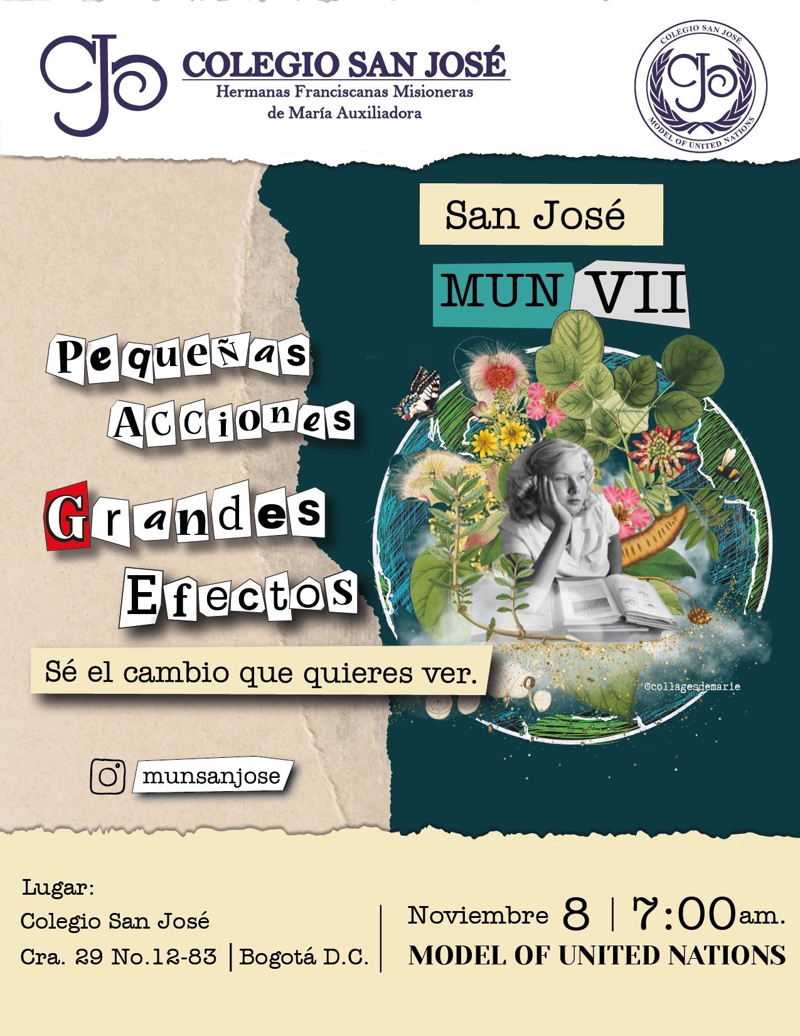

<sdf<sfasdfdasfdasf

Tabla de contenido

Introduction letter 3

Introduction to the Security council 4

2. Comission topic 6

Delivery of humanitarian aid in Gaza 6

3. Historical context 7

4. Focus of the comitee 8

4.1 Approach 1: True reasons: the ends and the means of each side in this conflict. 8

Introduction: 8

Key points/critical issues: 8

Research questions: 8

4.2 Approach 2: What has caused the lack of access to humanitarian aid? 8

Introduction: 8

Key points/ critical issues: 8

Research questions: 9

4.3 Approach 3: The economic aspects. 9

Introduction: 9

Key points/ critical issues: 9

Research questions: 9

5. Qarmas 9

Referencias 11

Introduction letter

Acta, non verba (Actions, not words)

Our warmest greetings to the delegates chosen for this commision of security council, our president Sofia Nova Ortiz and vice-president Nicole Páez Castañeda welcome you with their best wishes to this commision, both of them will take the position of chairwomen and encourage their readers to enter an adequate state of mind to participate skillfully in this United Nations model, we look forward to the possible solutions that the delegates will present according to the matter in hand. If you have any problem or questions don´t hesitate to contact us, remember we are here to help you in this activity.

With our best regards,

Nicole Alejandra Páez Castañeda

Phone number:3003966991

E-mail: paezcastañedanicolealejandra@familiajoseista.org

Sofia Nova Ortiz

Phone number: 3214582788

E-mail: novaortizsofia@familiajoseista.org

Security council president

San José MUN, 2024                              Security council vice-president

San José MUN, 2024

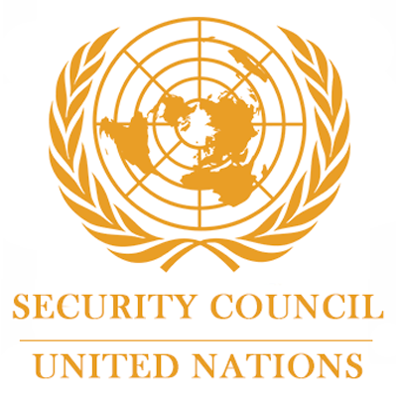

Introduction to the Security council

The Security Council has primary responsibility for the maintenance of international peace and security. The Security Council takes the lead in determining the existence of a threat to the peace or act of aggression. It calls upon the parties to a dispute to settle it by peaceful means and recommends methods of adjustment or terms of settlement. In some cases, the Security Council can resort to imposing sanctions or even authorize the use of force to maintain or restore international peace and security. (Reliefweb, s.f.)

¿ Which principal organ does the commission depend on?

The United Nations has six principal organs: the General Assembly, the Security Council, the [Economic and Social Council](https://www.britannica.com/topic/Economic-and-Social-Council), the [Trusteeship Council](https://www.britannica.com/topic/Trusteeship-Council), the International Court of [Justice](https://www.merriam-webster.com/dictionary/Justice), and the [Secretariat](https://www.britannica.com/topic/Secretariat-UN). (Encyclopedia Britannica, 2023)

¿What topics are dealt with?

Amongst its agenda the security council has (Security council report, s.f.):

Health Crises, Human Rights, Protection of Civilians, Armed Conflict, Counter-Terrorism, etc.

¿What can and cannot this comission do?

the Security Council has the purpose to maintain international peace and security; to develop friendly relations among nations; to cooperate in solving international problems and in promoting respect for human rights; and to be a centre for harmonizing the actions of nations. It does not have the authority to enforce desitions with military of its own nor to declare war on any country. (United Nations, s.f.)

¿ What are the prioritized Sustainable Development Goals for this commission?

The Security Council's primary focus is maintaining international peace and security, however it does not prioritize individual Sustainable Development Goals (SDGs), the most identifieable one would be goal number 16: Peace, justice and strong institutions. The SDGs are a set of 17 global goals adopted by the UN General Assembly to achieve a better and more sustainable future for all.

A word from the president:

As the president of this commission, I look forward to the solutions the delegates will come up with but specially to the debate arguments of each of our delegates, after all, it is one of the objectives to improve their talking and argument formulating abilities which will become useful to defend a position.

Expectations:

We expect a great debate with the delegates defending the political position of their respective countries with thought-out arguments and proposing solutions based on the resources of their countries.

Functions of the Security Council

* Manage health Crisis
* Justice, Rule of Law and Impunity
* Protect human Rights
* Protection of Civilians
* Women, Peace and Security
* Youth, Peace and Security
* Children and Armed Conflict
* Counter-Terrorism
* Control small Arms
* Lead arms Control and Disarmament, including small arms
* Take care of drug Trafficking and Security
* Energy, Climate and Natural Resources
* Piracy
* Non-Proliferation
* Information and Communication Technologies

# 2. Comission topic

## Delivery of humanitarian aid in Gaza

The war in Gaza is one of the oldest yet recent conflicts known to man. Every war brings with itself harm and hunger , to solve this organizations have grouped important supplies such as water, food or medical provisions and sent them to the most affected places in conflict.

The United Nations security council has estimated that only 43% of primary care health centers are functional, and 2.15 millions of people are projected to face crisis, or worse, levels of food insecurity. (UN news, 2024)

According to the Norwegian refugee council (Norwegian Refugee Council, 2024):

New data has revealed the scale of aid obstruction, and the consequential drastic fall in aid entering Gaza. This is driving a humanitarian disaster, with the entire population of Gaza facing hunger and disease, and almost half a million at risk of starvation.

While Israeli military attacks on Gaza intensify, lifesaving food, medicine, medical supplies, fuel, and tents have been systematically blocked from entering for almost a year.

Data analysis by organisations working in Gaza has found that as a consequence of the Israeli government's obstruction of aid:

83% of required food aid does not make it into Gaza, up from 34% in 2023.This reduction means people in Gaza have gone from having an average of two meals a day to just one meal every other day. An estimated 50,000 children aged between 6-59 months urgently require treatment for malnutrition by the end of the year.

65% of the insulin required and half of the required blood supply are not available in Gaza.

Availability of hygiene items has dropped to 15% of the amount available in September 2023. One million women are now going without the hygiene supplies they need.

Only around 1,500 hospital beds in Gaza remain operational, compared to around 3,500 beds in 2023 which was already well below sufficient to meet the needs of a population of more than 2 million people. By comparison, cities of similar size, such as Chicago and Paris average 5 to 8 times more beds than in Gaza.

1.87 million people are in need of shelter with at least 60% of homes destroyed or damaged (January 2024). Yet tents for around just 25,000 people have entered Gaza since May 2024.

3. Historical context

The first israelite tribes settled down in the territory known as Palestine in the late bronze age; from 1500 to 1000 b.C (Editors of Encyclopedia Britannica, 24) ; they didn’t stablish firmly until the early 12th century (Brice, 2023), The muslim conquered Palestine around 638 a.C and from that point onwards Islam has been the dominant religión and lifestyle of the región. After the Otoman empire’s collapse Palestine falls under british control from 1917 to 1948, when a scheme proposed by the UN in 1947 was executed, this plan would divide the territory as follows: 54% of the historical palestine would be given to Israel and its inmigrants who had settled down betwwen the early and mid-twentieth century. This territory borders the al-Aqsa mosque, which is a sacred place for both muslims and jews; it is believed that Solomins temple was located there before its destruction. (Hroub, 2006)

After the division of Palestine’s territory, Israel started to agressively claim more and more of Palestine’s zone, this wound up in a war that has never quite stopped (Chughtai, 2023). Thus is the reason for this gathering, any war has devastating consequences and this one is no exception.

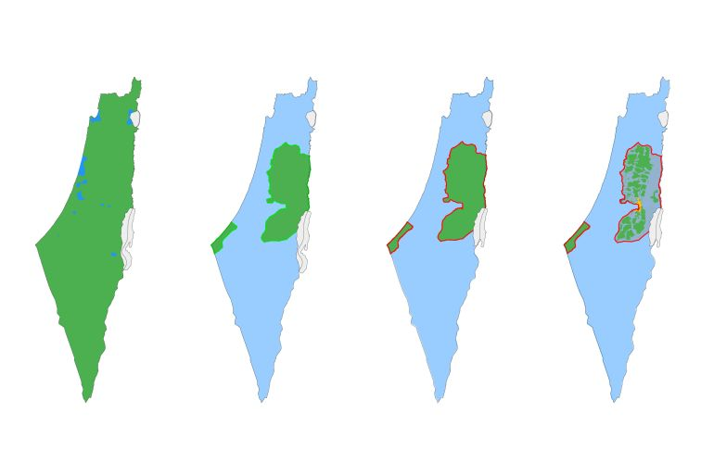

The delivery of humanitatian aid has become a great challenge due to the blockage happening in the zones that need it.

4. Focus of the comitee

4.1 Approach 1: True reasons: the ends and the means of each side in this conflict.

Introduction:

It´s important to know the explanation of the conflict, due to is necessary to understand the problem and the implications of this, the idea is learn about politic positions depending of your country and the implications of does desitions in the international setting.

Key points/critical issues:

The amount of lives and infrastructure lost to the bombings.

Who should take responsability for these loses? Legally speaking.

Thete is a discouse between who has the rights to the territory.

Research questions:

* What agreements have been signed? Have they been respected?
* Why has this war taken centuries to solve the conflict?
* What are the political statements of each part?
* How big is the role of Zionism in the war?
* What are the sides of the main countries about the conflict?
* Which countries are allied to either side?

4.2 Approach 2: What has caused the lack of access to humanitarian aid?

Introduction:

Along the conflict there have been dificulties to help the people in need based on etnical and religious reassons that are affecting minors, elder and widows. The clousure of the frontiers is just the top of the iceberg, the war has affected the infraestructure like: Roads, acueducts, hospitals, schools and refugees.

Key points/ critical issues:

The potential short-term consequences of the blockage in terms of human lives and loss of resources.

The potential long-term consequences of the blockage in terms of infrastructure.

There have been claims about funds and humanitarian aid being detoured, what could this mean for the citycens and the government?

Research questions:

* Who are those in charge of the humanitarian aid in the conflict?
* Who are the most vulnerable people in the conflict?
* What does your country done to help? (When it is choosen)

4.3 Approach 3: The economic aspects.

Introduction:

The continues atacks have produced the failure and the stops of functions of main industries and it made colaps the economy in Palestina. The companies are colapsed due to the war and that afects a lot the economy of both parts there is not energy, running water or other basic services.

Key points/ critical issues:

Countries have invested millions in either side wether it is in weapons or food and health aid, this could mean corruption.

Research questions:

* How are countries dealing with these isues?
* Is it posible for humanitarian aid to diminish the impact of war in the industry?
* What can be done to improve the economy in Gaza?

5. Qarmas

5.1 Important questions: The least you need to know

Introduction:

In the progress of the activity is important to show your opinion and your position about the topic, your participation is key to resolve the problematic. Next, thats the basic information that you already have to know for the activity.

Research questions:

* What is the political position of your country?
* What is your relationship with the countries involved?
* What is your relationship whith the problematic in general?
* Your country has participated in this problematic? And what has he done?
* If your country has not yet participated, what can he do or propose?

5.2 Keywords

Introduction:

Along the activity maybe you hear this words that we haven´t always used or know that it fully implies, this words must be help you to understand and discuss in the proper way.

Research words:

Historical context:

* Arab-Israeli conflict
* Israeli occupation
* Intafada
* Gaza blockade

Involved Parties:

* Israel
* Hamas
* Fatah
* Palestinians
* United Nations

Humanitarian Impact:

* Civilian casualties
* Refugees
* Displaced persons
* Humanitarian crisis
* Human rights

International Reactions:

* International condemnation
* Support for Palestine
* Support for Israel
* ONU resolutions
* Peace negotiations

Political Terms:

* Plestinian state
* Two-state solution
* Middle East peace
* Terrorism
* Resistance

Other Relevant Terms:

* Separation wall
* Gaza siege
* Smuggling tunnels
* Economic crisis
* Sustainable development

6. Research recommendation

Any link in the cybergraphy will prove itself useful in the long and hard task that is researching, we recommend our delegates to make use of them to familiarize themselves with the subject and connect it with their chosen country’s context.

Referencias

Brice, N. A. (20 de 09 de 2023). *The Iron age; Encyclopedia Britannica*. Obtenido de Encyclopedia Britannica: https://www.britannica.com/place/Palestine/The-Iron-Age

Chughtai, M. H. (27 de 11 de 2023). *Israel-Palestine conflict: A brief history in maps and charts; Aljazeera*. Obtenido de Aljazeera: https://www.aljazeera.com/news/2023/11/27/palestine-and-israel-brief-history-maps-and-charts

Editors of Encyclopedia Britannica. (17 de 07 de 24). *Bronze age ;Encyclopedia Britannica*. Obtenido de Encyclopedia Britannica: https://www.britannica.com/event/Bronze-Age

Encyclopedia Britannica. (04 de 09 de 2023). *UN-Security Council*. Obtenido de Encyclopedia Britannica: https://www.britannica.com/topic/United-Nations/Functions

Hroub, K. (2006). Hamás: an introductory guide. En K. Hroub, *Hamás: an introductory guide* (pág. Introduction). Pluto Press.

Norwegian Refugee Council. (16 de 09 de 2024). *Blockage of food aid; Norwegian refugee council*. Obtenido de Norwegian refugee council: https://www.nrc.no/news/2024/september/israels-siege-now-blocks-83-of-food-aid-reaching-gaza-new-data-reveals/

Reliefweb. (s.f.). *Security council: Reliefweb*. Obtenido de Reliefweb: https://reliefweb.int/organization/un-sc

Security council report. (s.f.). *Security council report: General issues*. Obtenido de Security council report: https://www.securitycouncilreport.org/thematic-general-issues

UN news. (5 de 4 de 2024). *UN news; Gaza: ‘No protection’ for civilians, aid workers, Security Council hears*. Obtenido de UN news: https://news.un.org/en/story/2024/04/1148276

United Nations. (s.f.). *Security council: united nations*. Obtenido de UN: https://main.un.org/securitycouncil/en/content/what-security-council